Lab-2
ID : AF05054428
NAME : Vignesh S
Batch code : ALP33393
Module : Data Visualization
TASK 2
- Create Following table or dataset to find insurance amount based on customer id
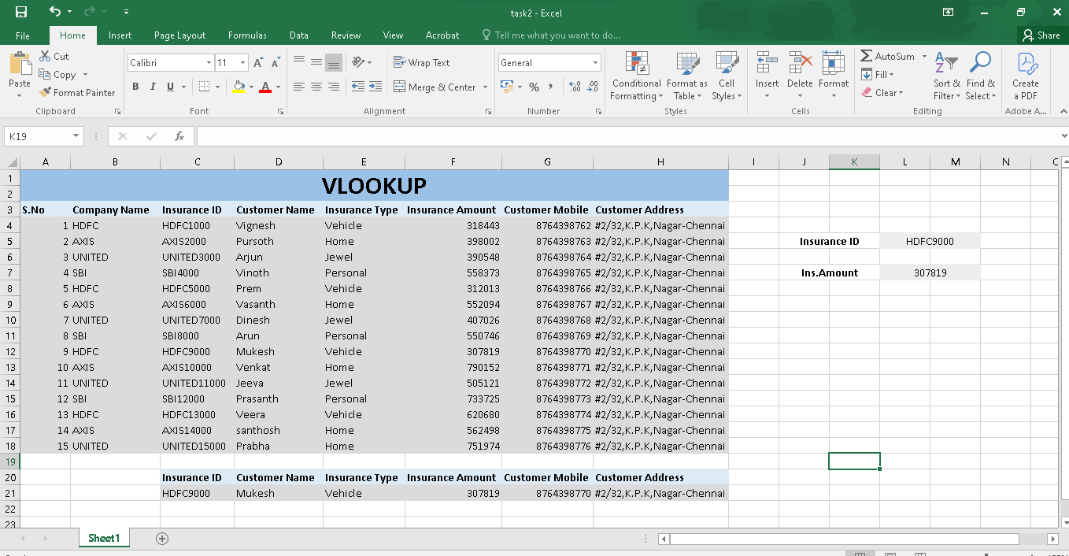
Formula :
1.Vlookup (Single Value)
=VLOOKUP(L5,C3:H18,4,FALSE)
2.Vlookup (Single to Multi)
=VLOOKUP(L5,C3:H18,{1,2,3,4,5,6},FALSE)
Explanation :
This task about using VLOOKUP in excel to find Insurance details based on Customer ID .In a single to single lookup, One ID returns one insurance amount. In a single to multi lookup , One ID returns multiple insurance records.

